HackerRank Program 4
Link :- https://www.hackerrank.com/challenges/printing-pattern-2/problem
Successful Submission
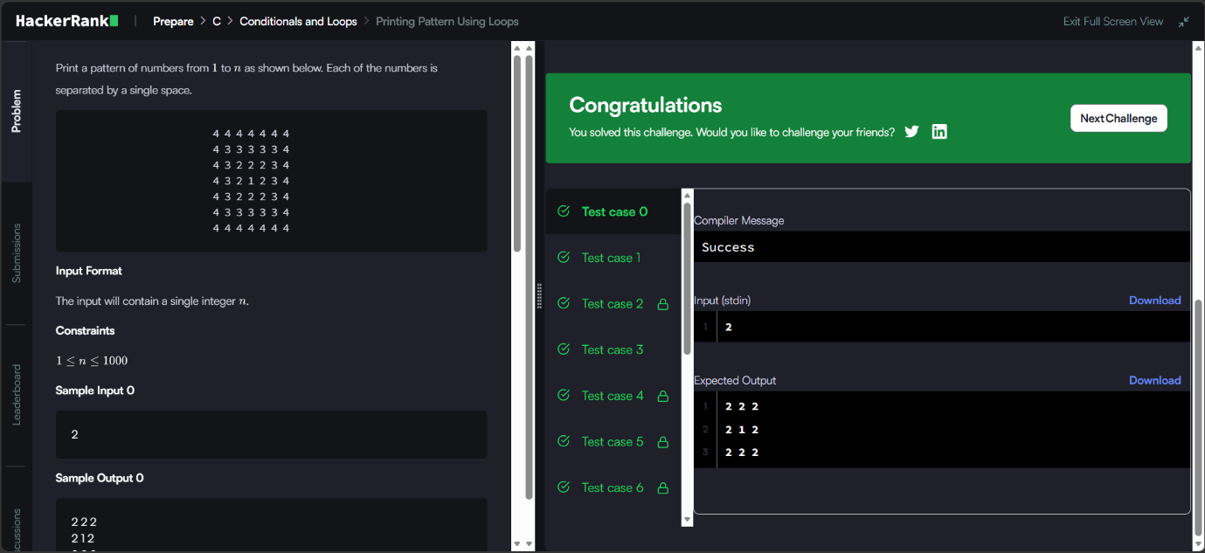
Source Code


